LANDIS-II

Climate Library v

User Guide

Melissa S. Lucash

Robert M. Scheller

Portland State University

Last Revised: February 27, 2015

# Table of Contents

1 Introduction 2

1.1 Interface between Succession and Climate Library 2

1.2 Acknowledgments 3

2 Climate Library Configuration File 4

2.1 LandisData 4

2.2 ClimateTimeSeries (Future climate data) 4

2.2.1 Monthly_AverageAllYears 4

2.2.2 Monthly_RandomYear 4

2.2.3 Monthly_SequencedYears 5

2.2.4 Daily_AverageAllYears 5

2.2.5 Daily_RandomYear 5

2.2.6 Daily_SequencedYears 5

2.3 ClimateFile 6

2.4 ClimateFileFormat 6

2.4.1 Monthly_Temp-C_Precip-mmMonth 6

2.4.2 Daily_Temp-C_Precip-mmDay 7

2.5 SpinUpClimateTimeSeries 7

2.6 SpinUpClimateFile 8

2.7 SpinUpClimateFileFormat 8

3 Climate Input Files 8

4 Climate Output Files 10

4.1 Climate-spinup-input.csv 10

4.2 Climate-future-input.csv 11

4.3 Century-succession-monthly-log.csv 11

4.4 Climate-annual-log.csv 12

5 Example Inputs 1

5.1 Main Climate Configuration (“Climate Config”) File 1

5.2 Climate Input File (ClimateFile or SpinUpClimateFile) 1

# Introduction

This document describes the climate library for the LANDIS-II model. For information about the LANDIS-II model and its core concepts including succession, see the *LANDIS‑II Conceptual Model Description.*

The role of the climate library is to create a central repository of climate data so that all the model extensions will ‘feed’ off of the same stream of climate.

The library can directly utilize daily or monthly climate data available from PRISM (baseline or historic climate data) and the USGS Geo Data Portal (climate change data). The output data will be aggregated to the ecoregion level, the fundamental climate unit of LANDIS-II and then delivered to LANDIS-II as either monthly or daily for the requested time period in a common format (comma delimited with a header). These data will be read into a new climate library (a sharable body of code) that will perform all necessary pre-processing for all climate-dependent LANDIS-II extensions.

Each extension requires slightly different climate data inputs; the succession extension will serve as the nominal controller of the climate library (activating it with necessary input file(s)). Such deep integration across ecological processes (extensions) allows LANDIS-II to respond to climate in a coordinated fashion at each model time step and allows climate variability to produce realistic emergent properties of species composition, disturbance regimes, and ecosystem dynamics (e.g., carbon cycling). This integration will also facilitate rapid deployment and will minimize the pre-processing overhead typical of many landscape models.

## Interface between Succession and Climate Library

The Climate Library was designed to be used with any succession extension. The information below uses the Century Succession version 4.0 extension as an illustrative example. **Century Succession v 4.0 is also the only succession extension for which the Climate Library has been integrated as of September 2014.**

***Note: The Climate Library must be initiated from within a succession extension. The Climate Library will not work with other extension, e.g., MultiRegimeFire, if the succession extension operating does not initialize the Climate Library, as below.***

With the Climate Library, the user specifies an intermediate text file that then refers to all the climate data. It is similar to the scenario file in that it is the master climate file that specifies which options and which files to use. In the example below, the keyword ClimateConfigFile refers to a file called “climate-generator-CC.txt”. The file “climate-generator-CC.txt” is the climate configuration file for the climate library.

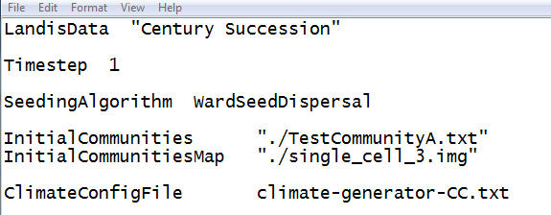

## Acknowledgments

Funding for the development of the climate library has been provided by USDA AFRI grant.

# Climate Library Configuration File

The text in the climate configuration file must comply with the general format requirements described in section 3.1 *Text Input Files* in the *LANDIS‑II Model User Guide*.

## LandisData

This parameter’s value must be "Climate Config".

## ClimateTimeSeries (Future climate data)

This data is used to specify the options for ‘future’ data, i.e. the climate used during the simulation years of the model (from time=0 until the end of the simulation). It does not refer to the spin-up data (see section 2.5).

There are six valid values for the ClimateTimeSeries input parameter: Monthly_AverageAllYears, Monthly_RandomYears, Monthly_SequencedYears, Daily_AverageAllYears, Daily_RandomYears, and Daily_SequencedYears. Each one is described below.

### Monthly_AverageAllYears

If the ‘Monthly_AverageAllYears’ option is used, the user will need to supply monthly data in the input file. The climate library will calculate mean monthly temperature and total monthly precipitation **across all years included in the input file.** Then it will use those calculated temperature and precipitation values for each month in each year of the simulation; **this means that the climate will be the same for each year of the simulation.**

### Monthly_RandomYears

If the ‘Monthly_RandomYear’ option is used, the user will need to supply monthly data in the input file. For each year of the simulation, the climate library will randomly select a years’ worth of climate data at a monthly time step. For example, if the user supplies data for years 2014-2015, the climate library might choose the climate in year 2015 for year 1 of the simulation and year 2014 as year 2 of the simulation. The climate library will not give any preference for chronological order.

### Monthly_SequencedYears

If the ‘Monthly_SequencedYears’ option is used, the user will need to supply monthly data in the input file. **The years in the input file will correspond exactly with the data used by LANDIS during the simulation.**  For example, if the user supplies climate data for years 2010 to 2015, then the model will run using 2010 as time= 1 in the simulation. Simulation years 2-6 will correspond to years 2011 to 2015 in the input data. If the duration of the simulation exceeds the number of years supplied, the last year of input data will be repeatedly used as climate data until the simulation is complete.

### Daily_AverageAllYears

If the ‘Daily_AverageAllYears’ option is used, the user will need to supply daily data in the input file. **For extensions requiring daily data** (e.g. Dynamic Fire), the climate library will take all the daily data for all the years of the input data and calculate an average of temperature (sum for precipitation) **across all years for each day of the simulation.** Then it will use that **average** (or sum) for each day for each year of the simulation; **this means that the climate will be the same for each year of the simulation.**

**For extensions requiring monthly data** (e.g. Century), the climate library will take all the daily data for all the years of the input data and calculate an average of temperature (sum for precipitation) **across all years for each month of the simulation.** Then it will use that **average** (or sum) for each month for each year of the simulation; **this means that the climate will be the same for each year of the simulation.**

### Daily_RandomYears

If the ‘Daily_RandomYears’ option is used, the user will need to supply daily data in the input file. The climate library will take all the daily data and calculate an average of temperature (sum for precipitation) for **each month and year.** For each year of the simulation, the climate library will randomly select a years’ worth of climate data at a monthly time step (see Monthly_RandomYears for more details).

### Daily_SequencedYears

If the ‘Daily_SequencedYears’ option is used, the user will need to supply daily data in the input file. The years in the input file will correspond exactly with the data used by LANDIS during the simulation (see Monthly_SequencedYears for more details).

For extensions requiring daily data (e.g. Dynamic Fire), no additional processing is necessary**.** For extensions requiring monthly data (e.g. Century), the climate library will calculate an average of temperature (sum for precipitation) **for each month and year of the simulation.**

## ClimateFile

This parameter references the file that contains all the climate data. Minimum temperature, maximum temperature and precipitation are **required** by the climate library. The units of temperature and precipitation are determined by the ClimateFileFormat parameter (see section 2.4).

Other parameters are **optional** and include wind speed, wind direction and nitrogen deposition. Nitrogen deposition is in units of g/m2/y. Wind speed must be in m/s. Wind direction must be expressed in terms of degrees where the wind is coming FROM. The wind data are in the same units used by the University of Idaho Gridded Surface Meteorological data (http://metdata.northwestknowledge.net/), which provides their wind data on the USGS data portal.

Details about how to configure the ClimateFile are described in Chapter 3.

## ClimateFileFormat

This parameter specifies the type of format for the ClimateFileFormat. There are currently six options (Monthly_Temp-C_Precip-mmMonth, Monthly_Temp-K_Precip-kgm2Sec, Monthly_Temp-K_Precip-mmMonth, Daily_Temp-C_Precip-mmDay, Daily_Temp-K_Precip-kgm2Sec and Daily_Temp-K_Precip-mmDay) described below.

### Monthly_Temp-C_Precip-mmMonth

If this option is used, the climate will need to be supplied on a monthly basis. Temperature will need to be in units of Celsius. Precipitation will need to be expressed in units of mm per month.

User tip: These units are commonly used for PRISM, IPCC3 (3rd assessment of IPCC in 2007) and IPCC5 (5th assessment of IPCC in 2011) data.

### Monthly_Temp-K_Precip-kgm2Sec

If this option is used, the climate will need to be supplied on a monthly basis. Temperature will need to be in units of Kelvin. Precipitation will need to be expressed in units of kg m-2 sec-1.

User tip: These units were sometimes used in by IPCC5.

### Monthly_Temp-K_Precip-mmMonth

If this option is used, the climate will need to be supplied on a monthly basis. Temperature will need to be in units of Kelvin. Precipitation will need to be expressed in units of mm per month.

User tip: These units were sometimes used in by IPCC5.

### Daily_Temp-C_Precip-mmDay

If this option is used, the climate will need to be supplied on a daily basis. Temperature will need to be in units of Celsius. Precipitation will need to be expressed in units of mm day-1.

User tip: These units are commonly used for the Mauer dataset, IPCC3 and IPCC5 data.

### Daily_Temp-K_Precip-kgm2Sec

If this option is used, the climate will need to be supplied on a daily basis. Temperature will need to be in units of Kelvin. Precipitation will need to be expressed in units of kg m-2 sec-1.

User tip: These units were sometimes used by IPCC5.

### Daily_Temp-K_Precip-mmDay

If this option is used, the climate will need to be supplied on a daily basis. Temperature will need to be in units of Kelvin. Precipitation will need to be expressed in units of mm per day.

User tip: These units were sometimes used by IPCC5.

## SpinUpClimateTimeSeries

This data is used to specify the options for ‘spin-up’ data, i.e. the climate used during the spin-up phase of the model.

There are six valid values for the SpinUpClimateTimeSeries input parameter (Monthly_Temp-C_Precip-mmMonth, Monthly_Temp-K_Precip-kgm2Sec, Monthly_Temp-K_Precip-mmMonth, Daily_Temp-C_Precip-mmDay, Daily_Temp-K_Precip-kgm2Sec and Daily_Temp-K_Precip-mmDay) which are the same options that can be used for ClimateTimeSeries. Each one is described above in section 2.2.

## SpinUpClimateFile

This parameter references the file that contains all the climate data (Tmin, Tmax and Precipitation) for the spin-up phase of the model. Details about how to configure the ClimateFile are described in Chapter 3.

## SpinUpClimateFileFormat

This parameter specifies the type of format for the SpinupClimateFile. There are currently six options (Monthly_Temp-C_Precip-mmMonth, Monthly_Temp-K_Precip-kgm2Sec, Monthly_Temp-K_Precip-mmMonth, Daily_Temp-C_Precip-mmDay, Daily_Temp-K_Precip-kgm2Sec and Daily_Temp-K_Precip-mmDay), described above in section 2.4.

# Climate Input Files

Climate data can be obtained from any source. One commonly used source of climate data is the USGS-GDP (<http://cida.usgs.gov/gdp/>). The USGS geodata portal serves downscaled (12 km resolution) data **projected** from multiple global circulation models and multiple emissions scenarios. The user can upload a shape file to their web site that enables their web server to parse the landscape byecoregion. The data is then downloaded by the user as **daily or monthly** means, variances and standard deviation for minimum temperature for each climate region for the requested time period in a common format (comma delimited with a header, Figure 3), maximum temperature (required) and mean precipitation (required) for each climate region for the requested time period in a common format (comma delimited with a header, Figure 3). Wind direction (optional), wind speed (optional) and nitrogen deposition (optional) are also available on the USGS data portal, but only for historical (i.e. not climate change) data.

One advantage of using the USGS data portal is that the TIMESTEP column is formatting correctly for the climate library (see Section 5.1), but this format could be generated from other datasets as well using R or Excel.

**At this time, the variances and standard errors from the USGS data portal are not utilized by the climate library.** These represent variation in the climate between grid cells; this is a small source of variation so it is not currently being used by the climate library. **However, variance and standard deviation are currently required as input parameters**, as this variation may be incorporated into calculations in future versions of the climate library.

**User tip:** If the user downloads multiple GCM and emission scenarios at one time (i.e., in one file), the user would need to parse the data by GCM and emissions scenario so that each input file contains **one** climate change scenario (e.g. Bcm2_a1b).

If there are multiple soil regions within each climate region, the user will need to copy the climate regions so that each ecoregion has a climate. For example, in the CNF+ landscape, there are five climatic regions (i.e. five polygons) so data was downloaded from the USGS data portal for the five regions. Then the data were copied from each climate region for each of the soil regions for a total of 25 ecoregions (5 climate regions * 5 soil regions = 25 ecoregions).

The user will need to adjust the headers in the climate input file. The columns for each ecoregion need to match the ecoregion names as they appear in the ecoregion.txt file. If there is an inactive ecoregion, the user should not supply climate data for that ecoregion. The user should list the inactive ecoregion first in the ecoregion.txt file and supply climate only for the active ecoregions.

The user will also need to have the correct key words to identify the data (i.e., if it’s max temperature, minimum temperature or precipitation, Table 1). Keep in mind that the words are **not case sensitive**. Wind direction, wind speed and nitrogen deposition data are optional (Table 2).

Table 1. Key words needed in climate input file for Tmin, Tmax and Precip.

|  |  |  |
| --- | --- | --- |
| Maximum  temperature | Minimum  temperature | Precipitation |
| # Tmax | # Tmin | # Prcp |
| # maxtemp | # mintemp | # ppt |
|  |  | # precip |

Table 2. Key words needed in climate input file if user is supplying data for wind direction, wind speed and/or nitrogen deposition. This data is optional.

|  |  |  |
| --- | --- | --- |
| Wind direction | Wind speed | Nitrogen deposition |
| # windDirect | #windspeed | # Ndeposition |
| # wd | #ws | # Ndep |
| # winddirection | #wind_speed |  |
| # wind_from_direction |  |  |

The climate data need to be supplied in specific units (Table 3). Some of the units are currently fixed (e.g. wind speed must always be in meters per sec), but others like temperature and precipitation can be adjusted using the ClimateFileFormat option (see section 2.4)

Table 3. Units required for the climate input file.

|  |  |  |  |  |  |
| --- | --- | --- | --- | --- | --- |
| Maximum  temperature | Minimum  temperature | Precipitation | Wind speed | Wind direction | Nitrogen deposition |
| Celsius | Celsius | mm | m/s | Degrees (FROM direction) | g/m2 |
| Kelvin | Kelvin |  |  |  |  |

# Climate Output Files

When the climate library is run (i.e. with Century Extension v3.1), there will now be four output files that contain climate data. A brief description of the files is below.

## Climate-spinup-input.csv

This file lists the temperature and precipitation data that was used during the spin-up phase of the model. **This file is useful for making sure that the spin-up climate file was read in properly.**

***Note: The time step in the Climate-spinup-input.csv file corresponds to the time step in the input file. For example, if you use daily data as your input, then the timestep in the Climate-spinup-input.csv will be daily as well.***

For a detailed description of each parameter in the output file, the user should open up the Spinup-Input-Log_Metadata.xml file located in the subfolder called Metadata/Climate-Library. The xml file can be opened in any internet browser (e.g. Internet Explorer, see below).

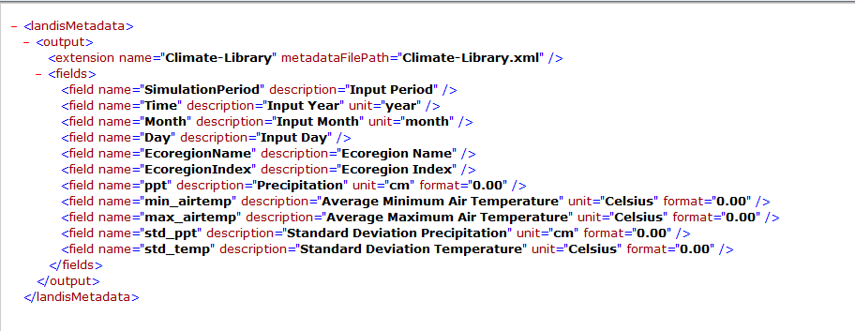

## Climate-future-input.csv

This file lists the temperature and precipitation data that was used during the future phase of the model. If wind speed, wind direction and/or nitrogen deposition were included as inputs, then these will also be provided in this file.

**This file is useful for making sure that the ClimateFile read in the data properly.** For a detailed description of each parameter in Climate-future-input.csv, the user should open up the Future-Input-Log_Metadata.xml file located in the subfolder called Metadata/Climate-Library.

## Century-succession-monthly-log.csv

This file summarizes the temperature and precipitation data on a monthly basis for the model run. This is the output file that is generated by the Century Extension. For a detailed description of each parameter in Century-succession-monthly-log.csv, the user should open up the MonthlyLog_Metadata.xml file located in the subfolder called Metadata/Century-Succession.



## Climate-annual-log.csv

This file summarizes several climate parameters (e.g. mean annual temperature, mean annual precipitation, begin growing season) on an annual basis for the model run. For a detailed description of each parameter in Climate-annual-log.csv, the user should open up the AnnualLog_Metadata.xml file located in the subfolder called Metadata/Climate-Library.

# Example Inputs

## Main Climate Configuration (“Climate Config”) File

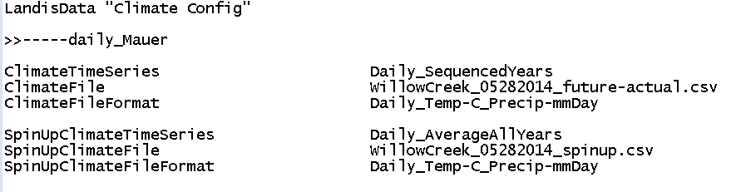

## Climate Input File (ClimateFile or SpinUpClimateFile)

